Autonomous Car Final Project

Introduction
Autonomous vehicles are a major innovation in modern transportation. These systems rely on artificial intelligence and computer vision in order to understand their surroundings and make safe driving decisions. One of the most important capabilities of autonomous systems is the ability to detect and interpret traffic signs. Traffic signs provide essential information such as warnings, directions, and traffic regulations. This project focuses on building a system that detects traffic signs in images using artificial intelligence techniques, demonstrating a simplified version of a real-world perception system.

Problem Description
Traffic sign detection in real-world environments is a challenging problem. Unlike controlled environments, road scenes include many variations that affect detection performance. These variations include different lighting conditions, viewing angles, occlusions, motion blur, and distance from the camera. In many cases, traffic signs may be partially hidden or appear very small, making detection more difficult. Because of these challenges, traditional rule-based approaches are not sufficient, and machine learning methods are required.

Project Goal
The goal of this project is to create a system that can detect traffic signs in images. The system receives an image as input, processes it using an AI model, and highlights detected traffic signs using bounding boxes. This approach simulates a perception module of an autonomous vehicle. The system was designed according to the following requirements: The system must receive an image as input. The system must process the image using a trained AI model. The system must detect traffic signs within the image. The system must display the results using bounding boxes. These requirements demonstrate the ability of AI to identify relevant objects in visual data.

Technologies Used
The project was implemented using Python in a Google Colab environment. OpenCV was used for image processing and visualization. The detection model used is YOLO (You Only Look Once), a deep learning model designed for object detection. YOLO processes the entire image in a single pass, making it efficient and suitable for real-time applications. This model is widely used in computer vision tasks such as autonomous driving.

System Design
The system operates through a simple pipeline. First, the user uploads an image. Next, the model processes the image and searches for visual patterns associated with traffic signs. The system then draws bounding boxes around detected objects. Finally, the processed image is displayed to the user. This pipeline represents a simplified version of real-world perception systems.

Object Detection
Object detection is a computer vision task that identifies objects and their positions within an image. Unlike classification, object detection provides both the category of the object and its location. This is important for autonomous vehicles, which must understand not only what objects exist, but also where they are located.

Results and Analysis
The system was tested on multiple real-world images. In many cases, large and clearly visible traffic signs were detected successfully. However, smaller or distant signs were more difficult to detect. In some images, only part of the traffic signs were detected. The results show that detection performance depends on visual conditions such as size, distance, and lighting. In complex environments with many objects, the model sometimes produces errors.
This street contains two "No Entry" signs.
In this example, the system successfully detects both "No Entry" signs and highlights them using bounding boxes.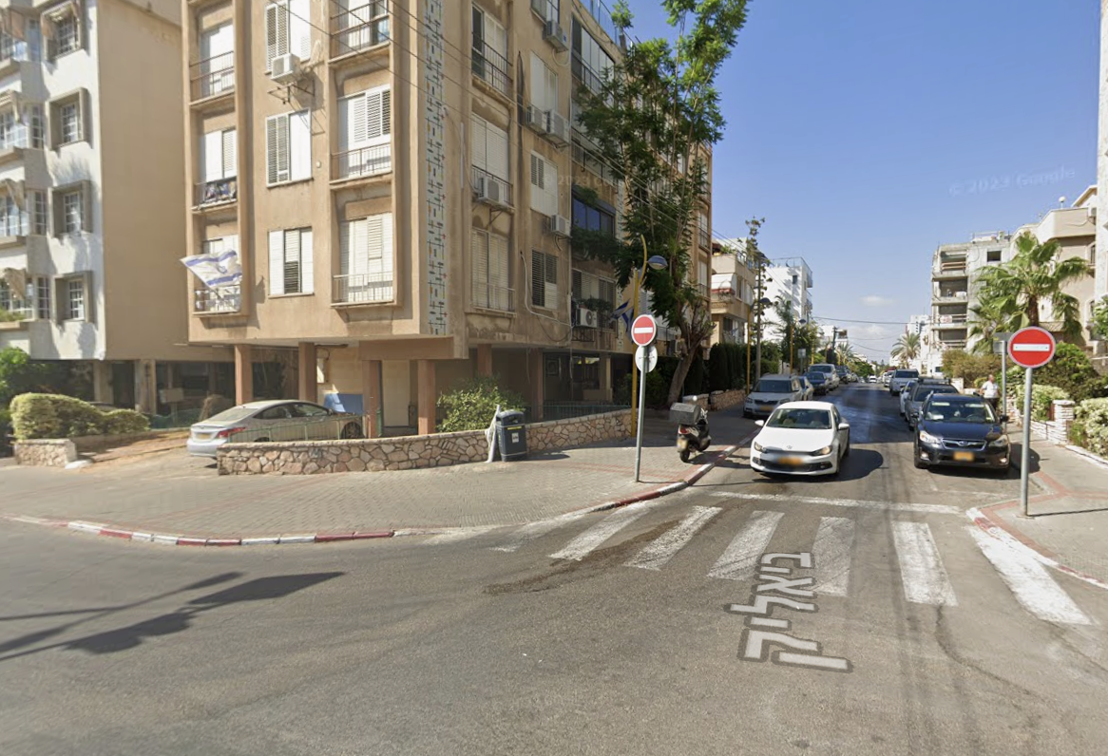Original image of the street scene.
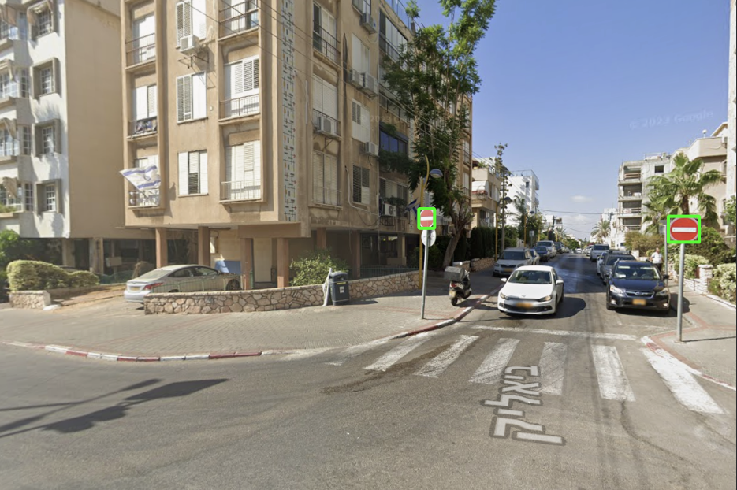Detection result showing identified traffic signs using bounding boxes.
Limitations
The system does not achieve perfect accuracy. In some cases, traffic signs are missed, which are known as false negatives. In other cases, objects that are not traffic signs are detected incorrectly, known as false positives. The model is sensitive to environmental conditions such as lighting, distance, and angle. Additionally, the model does not truly understand the meaning of objects, but relies on learned visual patterns.

Autonomous Vehicles Context
This project demonstrates only a small part of a complete autonomous driving system. In real-world systems, multiple sensors are used, including cameras, radar, and LiDAR. These systems combine data from different sources to improve accuracy. They also analyze data continuously over time, rather than relying on a single image. This allows real autonomous vehicles to operate more reliably.

Conclusion
This project demonstrates how artificial intelligence can be used to detect traffic signs in images. The system performs well in many cases and provides clear visual output. At the same time, it highlights the challenges and limitations of real-world AI systems. Overall, the project presents a practical application of AI in autonomous vehicles.

Additional Improved Theory Section

Computer Vision and Object Detection Background
Computer vision allows a computer to interpret visual information from images and video. A digital image is represented as a matrix of pixels, and every pixel contains numerical color values. In road scenes, the computer must use these pixel patterns to identify meaningful objects such as lanes, vehicles, pedestrians, and traffic signs.
This project uses object detection rather than simple image classification. Classification only answers what appears in an image, while object detection answers both what appears and where it appears. This is important for autonomous vehicles because knowing that a sign exists is not enough; the system also needs to know its location in the scene.
Each model prediction contains a bounding box, a class label, and a confidence score. The bounding box marks the location of the detected sign, the class label describes the object type, and the confidence score represents how certain the model is about the prediction.

System Workflow
The system works as a perception pipeline. First, the user uploads a road image in Google Colab. The image is read with OpenCV and resized to 640 by 640 pixels because many object-detection models expect a fixed input size. The resized image is then sent to the Roboflow inference API.
The model returns a JSON response with the predicted detections. Since the model works on the resized image, the returned coordinates must be converted back to the original image size. The program calculates scale factors for the width and height and uses them to place the bounding boxes correctly on the original image.
Finally, OpenCV draws green rectangles around the detected traffic signs and displays the processed image. This creates a clear visual output that demonstrates how the AI model interpreted the road scene.

Evaluation and Limitations
The system performs best when signs are large, clear, and close to the camera. In these cases, the model can usually identify the sign and draw an accurate bounding box. However, performance becomes weaker when signs are small, far away, blurry, partly hidden, or affected by difficult lighting conditions.
Two important error types are false positives and false negatives. A false positive happens when the system detects a traffic sign where there is no real sign. A false negative happens when a real sign appears in the image but the model misses it. These errors are common in real AI systems and show why testing is important.
A stronger evaluation could use precision, recall, and mean average precision. Precision measures how many detected objects were correct, recall measures how many real objects were found, and mAP is a common object-detection metric used to compare model quality.

Connection to Autonomous Vehicles
This project represents one part of a complete autonomous driving system: the perception layer. In a real autonomous vehicle, the output of this layer would be passed to planning and control modules. For example, a detected stop sign could trigger a stopping behavior, while a speed-limit sign could update the allowed driving speed.
Real autonomous vehicles combine camera perception with additional sensors such as radar, LiDAR, GPS, and maps. They also analyze information continuously over time rather than relying on a single image. Still, traffic sign detection remains an important example of how artificial intelligence supports safe navigation.

Future Improvements
Future work can improve the project by supporting video input, testing the model on a larger image dataset, calculating precision and recall, and comparing different confidence thresholds. Another useful improvement is to store the API key securely using Colab secrets or environment variables before uploading the project to GitHub.
The system could also be extended with a simple decision layer. For example, after detecting a stop sign, the program could display a simulated STOP command. After detecting a speed-limit sign, it could update a simulated speed policy. This would connect perception more directly to navigation behavior.

